Discovery Report
AURIX
3D Jewelry Visualization Model

AIA | ENTP 6314
TEAM
Snehila Bajracharya, sxb240043
Aarya Kanitkar, dal617877

SUBMITTED TO
Prof. Anavir Shermon

Executive Summary
Custom jewelry requires a 3D CAD model, creating challenges for small jewelers due to software costs of approximately $6,000, lengthy training, and designer fees ranging from $25 to $62 per hour. Aurix is a web application that allows customers and jewelers to design rings, nameplates, earrings, and pendants, adjust precise dimensions, and connect with craftsmen for manufacturing. Its AI feature allows users to describe their ideas through text prompts and generate designs. Although four companies introduced AI jewelry design tools in 2026, complex designs still require human review before manufacturing. Since online jewelry customization has existed since 2010, Aurix focuses on improving accessibility rather than introducing a completely new concept.
Our market analysis estimates a Total Addressable Market (TAM) of $18.8 million annually, a Serviceable Available Market (SAM) of $1.8 million to $4.9 million, and a Serviceable Obtainable Market (SOM) of $36,000 to $493,000, with a base case of $156,000. At $20 per month, subscriptions alone may not support a business capable of attracting significant venture capital investment. Higher pricing and a marketplace connecting customers, designers, and craftsmen could improve revenue and create a competitive advantage, although neither has been validated. Since the research relies on secondary sources and AI generated synthetic interviews, real customer interviews and demand testing are essential next steps.
1. The Market Problem and Why Now
1.1 The Problem
Creating custom jewelry requires a 3D CAD model before production. Small jewelers must either purchase expensive software, hire skilled designers, or outsource the work. Each option involves significant costs, time, and expertise, often delaying orders or forcing businesses to turn away customers. Aurix aims to simplify this process by making jewelry design more affordable and accessible.
1.2 How Severe Is the Problem?
Professional CAD software is expensive and difficult to learn. MatrixGold costs approximately $5,995, including Rhino 8 [5]. According to a 2011 JCK article, even experienced CAD users may need six to twelve weeks to become proficient in Rhino, while learning Matrix can take six months to a year [6]. Although these estimates are older, they demonstrate the technical challenges involved.
Hiring designers is another major expense. Recent job postings show hourly rates of $52 to $62 at David Yurman, $25 to $35 at Rio Casting, and starting at $30 at Bocaj Narima [8][9][10]. This translates to approximately $52,000 to $129,000 annually for full time employment. Industry reports also highlight difficulties finding skilled professionals [7]. The Bureau of Labor Statistics reported 32,800 jewelers employed in 2025, with median annual earnings of $52,540 and a projected 3% employment decline through 2035 [1].
Outsourcing can reduce costs but creates delays. CAD services typically charge $79 to $125 per design, with turnaround times of approximately two weeks and additional revision fees of $50 [12]. Finished custom jewelry may take 12 business days to six weeks, depending on the manufacturer [13]. Freelancers offer services starting at $50, although limited reviews make reliability difficult to assess [39].
Meanwhile, demand for customization appears to be increasing. The National Jewelers Association predicted that 68% of couples would prefer customized wedding bands in 2025, compared with 65% in 2023 [14]. Although these figures reflect projected preferences rather than actual sales, they suggest growing interest in personalized jewelry.
1.3 Why Current Solutions Fall Short
Existing solutions have limitations. Professional CAD software requires technical expertise, while platforms such as GemFind, Pencil, and Kickflip offer customization through predefined options at monthly prices ranging from $59 to $499 [15][27][28]. Outsourcing adds time and revision costs.
Our research did not identify a platform that clearly combines browser based design, precise dimensional controls, and direct access to independent craftsmen. Aurix aims to integrate these capabilities into one application.
1.4 Why Now?
Advances in AI have created new opportunities for jewelry design. In 2026, Diatech Studio introduced technology that converts reference images into CAD components [17], while Star Gems launched GemArt AI to generate jewelry concepts from prompts, sketches, and photographs [18]. Pencil introduced an AI agent capable of generating adjustable parametric designs intended for manufacturing [16], and RhinoArtisan 7.0 launched tools for creating organic 3D models from text descriptions [19]. However, these capabilities remain vendor claims without independent manufacturing validation.
Despite this progress, AI still faces technical limitations. Research shows that AI performs reasonably well with basic geometry but struggles with complex structures [20]. A benchmark involving 12,632 industrial design tasks found that advanced AI models generated executable code in 56% to 81% of cases, but achieved maximum geometric overlap scores of only 54% for solids and 22% for surfaces [21]. Another study found that executable designs do not always have accurate assembly structures [22]. These benchmarks were not specific to jewelry.
Manufacturing accuracy remains a concern. One company's testing found that only 55% of AI generated character models were fully watertight, while features smaller than 1 mm could be fragile [23]. This is particularly relevant for gemstone prongs. Diatech also acknowledges that its designs require human validation before production [17].
Online jewelry customization is not new. GemFind introduced its Ring Builder in 2010 [26], while DreamFusion demonstrated text based 3D generation in 2022 [25]. The recent opportunity lies in making existing design technology easier to use through natural language instructions.
Overall, AI can support structured jewelry designs, but reliable manufacturing of complex designs still requires human oversight. Aurix's opportunity is to combine accessible AI design tools, precise measurements, and manufacturing connections. However, growing competition makes differentiation essential.
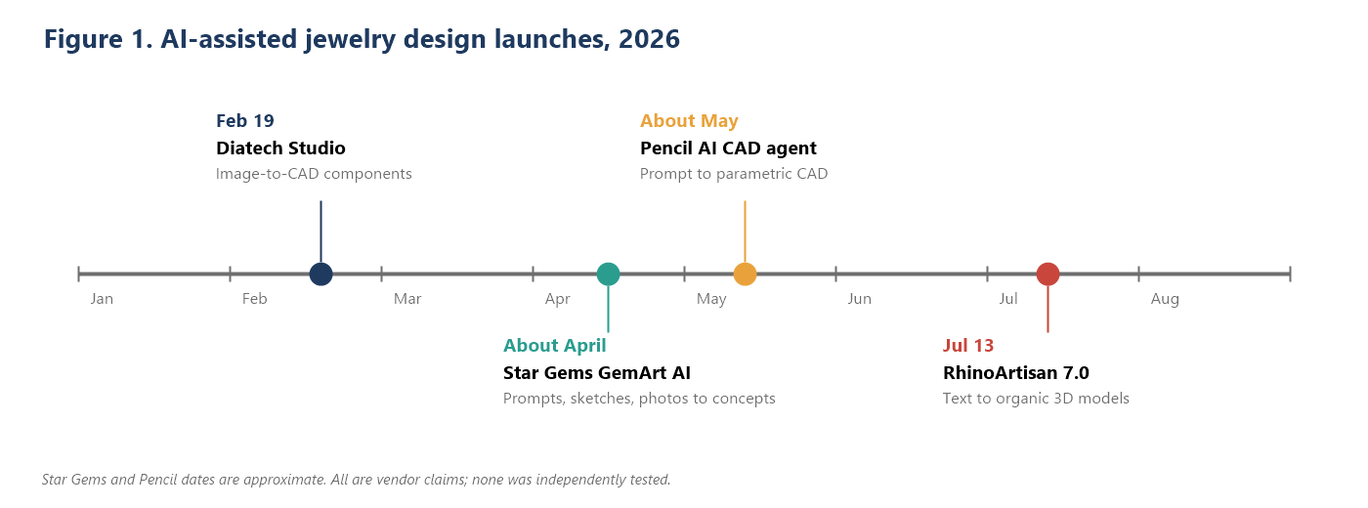
2. Market Size (TAM, SAM, SOM)
2.1 Method
We estimated Aurix's market potential using a bottom up approach based on the number of US jewelry businesses, their potential need for the platform, and an annual subscription price of $240 ($20 per month). Each market estimate narrows the customer base to provide a more realistic assessment of potential revenue.
2.2 Market Definitions
Total Addressable Market (TAM)
The TAM includes all US jewelry businesses that could potentially use Aurix. This consists of 19,348 jewelry retailers with employees [2], 1,879 jewelry manufacturers with employees [3], and 57,102 retailers without employees [4]. Together, these represent 78,329 businesses, giving Aurix an estimated TAM of $18.8 million annually at $240 per subscription, assuming every business subscribes (see Appendix B).
Serviceable Available Market (SAM)
The SAM focuses on smaller businesses more likely to need affordable design tools. This includes 16,671 retailers and 1,554 manufacturers with fewer than 10 employees [2][3], along with 57,102 businesses without employees [4]. Larger businesses were excluded because they may already have access to professional designers or software such as MatrixGold, priced at $5,995 [5].
Since not all small jewelers offer customization, we applied different assumed percentages based on their likelihood of needing CAD tools. Lower percentages were assigned to businesses without employees, as many may operate part time or primarily resell jewelry.
Serviceable Obtainable Market (SOM)
The SOM represents the share of the SAM Aurix could capture as paying subscribers. It is calculated using an assumed adoption rate and the annual subscription price of $240. These estimates reflect potential revenue under stable operating conditions rather than a specific year's forecast. Actual results will depend on customer demand, competition, pricing, and retention.
2.3 Results
 | Conservative | Base | Optimistic
TAM: all US jewelry businesses | 78,329 | 78,329 | 78,329
TAM annual revenue | $18.80M | $18.80M | $18.80M
Small employers (under 10 employees) | 18,225 | 18,225 | 18,225
Share needing a design tool (assumption) | 25% | 40% | 50%
No-employee sellers | 57,102 | 57,102 | 57,102
Share needing a design tool (assumption) | 5% | 10% | 20%
SAM: target customers | 7,411 | 13,000 | 20,533
SAM annual revenue | $1.78M | $3.12M | $4.93M
Paid adoption of the SAM (assumption) | 2% | 5% | 10%
SOM: paying customers | 148 | 650 | 2,053
SOM annual revenue | $35,573 | $156,002 | $492,790
In the base case, the SAM is about 17% of the TAM, and the SOM is 5% of the SAM.
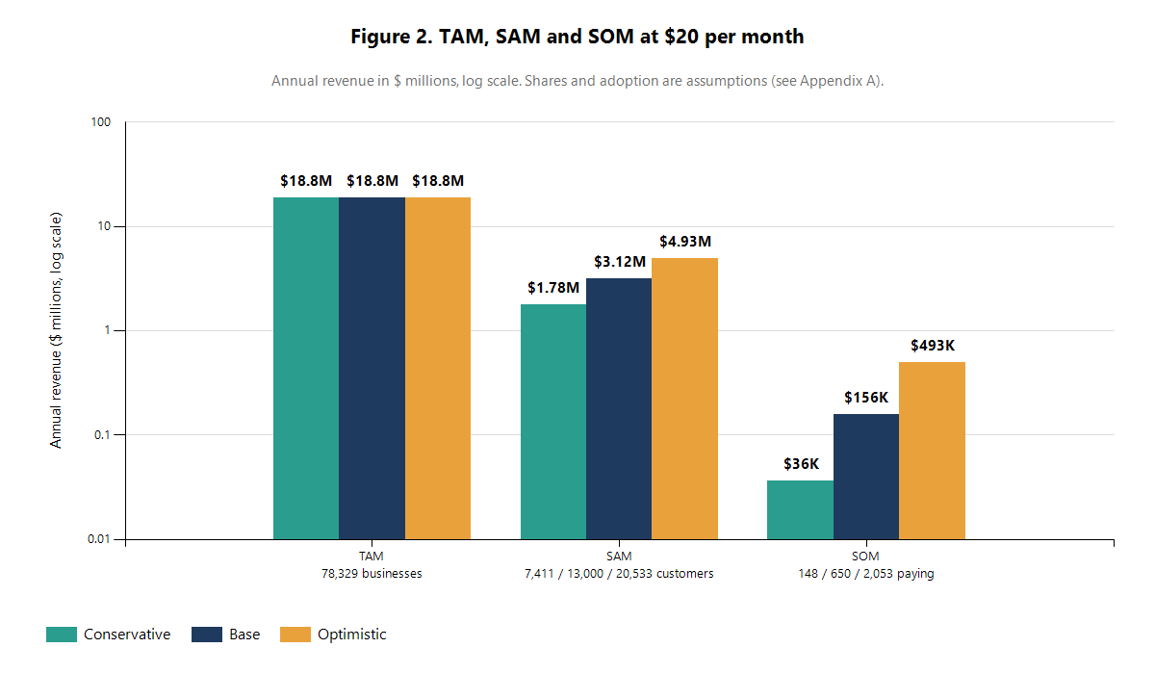
2.4 Sensitivity to Price
Subscription pricing directly affects Aurix's revenue potential. Our analysis compares different price points while keeping customer counts and adoption rates constant. However, higher prices could reduce adoption, especially among smaller jewelry businesses with limited budgets.
Price per month | TAM | SAM (base) | SOM (base)
$20 | $18.8M | $3.1M | $0.16M
$199 | $187.0M | $31.0M | $1.55M
Pencil's most affordable subscription plan costs $199 per month [15]. However, we have not yet determined whether small jewelry businesses would be willing to pay a similar price for Aurix.
2.5 What the Numbers Mean
At $20 per month, Aurix has limited subscription revenue potential. Even with full market adoption, annual revenue would reach only $18.8 million, while the estimated SAM ranges from $1.8 million to $4.9 million. Reaching $1 million in annual revenue would require approximately 4,167 subscribers, representing 20% to 56% of the SAM across our scenarios.
Although business counts come from 2022 and 2024 Census data, SAM and SOM estimates rely on assumptions. SOM is particularly uncertain because reliable adoption benchmarks for jewelry design software are unavailable. While 89% of small businesses reportedly use SaaS technology [37], this does not establish demand for Aurix.
2.6 What Is Excluded
Our estimates exclude individual consumers, craftsmen, manufacturers without employees, international customers, and marketplace commissions. These could expand Aurix's revenue potential, but their actual contribution requires further validation.

3. Customer Research
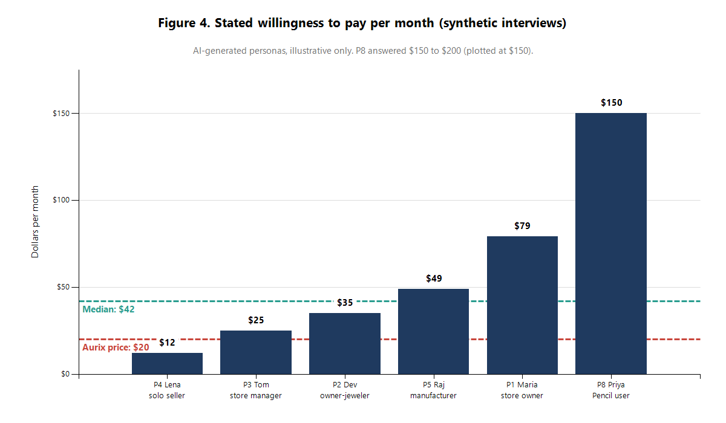
3.1 Research Approach
Our customer research relies on secondary sources, including jewelry forums, software reviews, job postings, and competitor pricing. No direct customer interviews have been conducted. Some Reddit, Capterra, and G2 pages were inaccessible, and app store reviews were not examined. Therefore, these findings provide preliminary insights that require validation through primary research.
[Team: Add the number of customer interviews, participant backgrounds, and key findings once interviews are completed.]

3.2 Target Customer
Aurix targets small jewelry businesses and independent sellers offering custom products without the resources for expensive CAD software or dedicated designers. Census data shows that approximately 86% of jewelry retailers with employees have fewer than 10 workers [2], making small businesses a significant potential customer segment.
3.3 Customer Feedback and Key Findings
Jewelry forums and software reviews highlight concerns about CAD costs, learning difficulties, and production delays. However, most jewelry specific discussions date from 2004 to 2013, so they reflect longstanding challenges rather than necessarily current experiences.
Jewelers have reported frustration with software costs, upgrades, and lengthy training [31][32]. More recent Rhino reviews from 2023 and 2024 also mention difficult interfaces and high costs [34]. Although Rhino serves multiple industries, these concerns remain relevant to smaller jewelry businesses.
Forum discussions suggest that CAD modeling can sometimes take as long as traditional hand carving, especially when creating multiple variations. Jewelers have also questioned whether digital renderings accurately represent finished products [31]. Some prefer focusing on production and customer service rather than learning CAD [33]. Software compatibility presents another challenge, as shown by a 2020 discussion about MatrixGold requiring an older Rhino version [35].
Pricing is also important. Kickflip reviews suggest that high subscription fees may discourage smaller businesses with limited sales [29]. Although these reviews are not jewelry specific, they indicate potential pricing concerns for Aurix.
3.4 Main Research Themes
Four concerns emerged: software and upgrade costs, time spent learning and creating CAD models, differences between renderings and finished jewelry, and subscription pricing sensitivity. Aurix could address these challenges through simpler design tools and reduced dependence on technical expertise. However, outdated jewelry discussions and reviews from other industries limit the strength of this evidence.
3.5 Areas for Further Research
We plan to interview small jewelers and independent sellers to understand their custom order volumes, CAD workflows, design expenses, willingness to trust AI generated models, and acceptable subscription prices. These interviews will help determine whether the identified problems create sufficient demand for Aurix. Proposed questions are included in Appendix D.
4. Competition
4.1 Who we compared
We chose five products relevant to web-based and AI-assisted custom jewelry design. This selection is our judgment, not a ranking by revenue.

 | Pencil | Star Gems GemArt AI | Kickflip | GemFind RingBuilder | MatrixGold
Pricing | $199 or $499/month [15] | Not published [18] | $59/month plus 1.95% falling to 0% per sale; add-ons $49 and $99/month [27] | $295 or $345/month [28] | $5,995 one-time [5]
Core features | Ring, pendant and nameplate builders; AI CAD agent; publish made-to-order designs [15][16] | Concepts from prompts, sketches and photos; bracelet, necklace and eternity-band configurators with real-time pricing; in-house CAD and manufacturing [18] | Real-time configurator, unlimited variants, engravings [27] | Online engagement-ring design and purchase; live diamond feeds [28] | Parametric modeling; design-to-manufacturing workflow; rendering and gem-setting tools [5]
Target customer | Shopify jewelers selling custom pieces [15] | Retail jewelers doing custom work [18] | Any customizable-product seller, jewelry among them [27] | Jewelers selling engagement rings online [28] | Jewelers, from students to experts [5]
Funding | $350K raised June 2024, per an aggregator (unverified) [38] | Not disclosed | Not disclosed | Not disclosed | Not disclosed

4.2 What Users Complain About
Customer feedback on existing platforms is limited. Pencil received three five star Shopify reviews in 2026, while GemFind received two in 2021, with no reported complaints [28][30]. However, these small samples cannot establish overall customer satisfaction.
Kickflip received 17 reviews rated one or two stars, citing pricing changes, technical problems, blank orders, Shopify integration difficulties, and poor customer support [29]. MatrixGold has also faced compatibility complaints involving Rhino, although discussions from 2020 to 2024 may not reflect its current performance [35][36].
4.3 Closest Competitor
Pencil is Aurix's closest competitor, offering customization for rings, pendants, and nameplates, along with an AI design agent introduced in 2026. However, its support for earrings and advanced dimensional controls could not be confirmed.
4.4 Gaps in the Market
Our competitor analysis suggests several potential opportunities for Aurix. None of the five competitors examined clearly combines independent customers, designers, and craftsmen in one manufacturing marketplace. Existing platforms primarily serve retailer storefronts, while GemArt AI uses its own factory and MatrixGold focuses on CAD design.
Aurix could also serve jewelers outside Shopify, enable customers to design jewelry directly, and provide affordable tools with precise measurements without extensive CAD training. With competing platforms starting around $49 to $59 monthly and some users reporting pricing concerns [29], affordability may help attract smaller businesses. However, these opportunities require further validation.
5. Defensibility and Moats 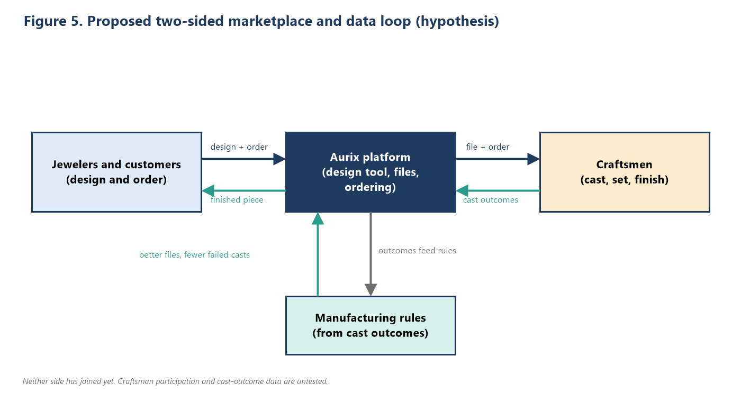
5.1 What Is Not a Competitive Advantage
AI assisted design alone is not a sustainable competitive advantage, as four competitors introduced similar features in 2026 [16][17][18][19]. Increasing access to AI technology also makes these tools easier to replicate. Similarly, an attractive interface and design features comparable to Pencil may improve usability but offer limited protection against competition.
5.2 Potential Competitive Advantages
Aurix's strongest potential advantage is a marketplace connecting customers, designers, and independent craftsmen. More customers could attract additional craftsmen, while a larger craftsman network would offer customers more manufacturing options. Saved designs and established relationships could also improve retention. However, participation from both groups remains unvalidated.
Manufacturing data could provide another advantage. Tracking successful and rejected designs would help Aurix improve material thickness, gemstone settings, and structural requirements, addressing limitations in current AI tools [17]. However, this depends on craftsmen sharing production outcomes.
Saved designs, pricing preferences, and reusable templates could further encourage retention, although competitors such as Pencil already offer similar features [16].
5.3 Competitive Threats
Pencil is a major competitor because of its existing customization and AI capabilities. Its reported $350,000 funding remains unverified [38]. Established companies such as Star Gems and Stuller may benefit from manufacturing resources and industry relationships. Wider access to AI technology also lowers barriers for new competitors.
5.4 Overall Assessment
Aurix currently lacks a proven competitive advantage. Its marketplace offers the strongest opportunity for long term differentiation, but its value remains untested.
Proposed first year milestones include onboarding approximately 25 craftsmen, generating repeat orders, and collecting manufacturing outcome data. These targets are not proven results, but achieving them would help demonstrate whether Aurix can build a competitive position beyond its design software.
6. Business Model and Unit Economics
6.1 Revenue Streams
Aurix plans to generate revenue through three sources: a $20 monthly subscription for jewelry design tools, commissions on manufacturing orders completed through its craftsman marketplace, and premium plans offering multiple user accounts, automated pricing estimates, and online store integrations. Competitors charge $49 to $499 monthly for comparable customization services [15][27][28]. However, customer willingness to pay for Aurix's premium features remains untested.
6.2 Planned Subscription Unit Economics
The subscription unit economics are based on initial financial assumptions, since competitors do not publicly disclose detailed operating costs or churn rates. These estimates assess potential profitability but require validation using actual customer acquisition costs, operating expenses, and retention data.
Metric | Assumption | Result
Price | $20/month | $240/year
Gross margin | 80% (hosting and AI inference) | $16/month contribution
Monthly churn | 4% | Average life 25 months
Lifetime value | $16 × 25 | $400
Target lifetime value to acquisition cost | 3:1 | Acquisition cost ceiling $133
Payback at that cost | $133 ÷ $16 | 8.3 months

Sensitivity to churn:
Monthly churn | Lifetime value | Acquisition cost ceiling (3:1)
3% | $533 | $178
4% | $400 | $133
6% | $267 | $89
6.3 What the Base Case Means for the Business
Under the base case scenario, Aurix would have approximately 650 paying subscribers, generating $156,000 in annual revenue. Assuming an 80% contribution margin, the business would retain approximately $125,000 after variable costs, equivalent to $192 per customer annually.
If annual fixed operating costs were $300,000, Aurix would need approximately 1,563 subscribers to break even through subscription revenue alone. This is more than twice the base case estimate and close to the optimistic projection of 2,053 subscribers. These calculations suggest that a $20 monthly subscription would not be sufficient to cover operating costs under the base or pessimistic scenarios. Only the optimistic scenario would exceed the estimated break even point.
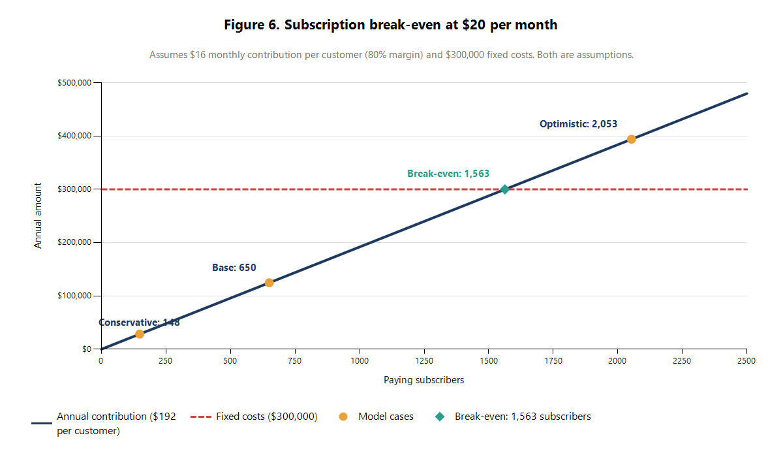
6.4 Potential Impact of the Marketplace
Aurix could increase revenue by charging a 10% commission on manufacturing orders. While existing CAD and wax services charge $79 to $200 [12], we estimate completed jewelry orders would cost $150 to $500, generating $15 to $50 in commission per transaction.
Assuming 650 subscribers place an average of 0.5 orders monthly, with a $30 commission per order, the marketplace could generate $117,000 annually, increasing total revenue to approximately $273,000.
However, these projections are unverified. Success depends on attracting skilled craftsmen, generating repeat orders, and keeping transactions on the platform. Customer research and marketplace testing are needed to assess financial sustainability.
6.5 Price scenarios (base-case SOM of 650 customers)
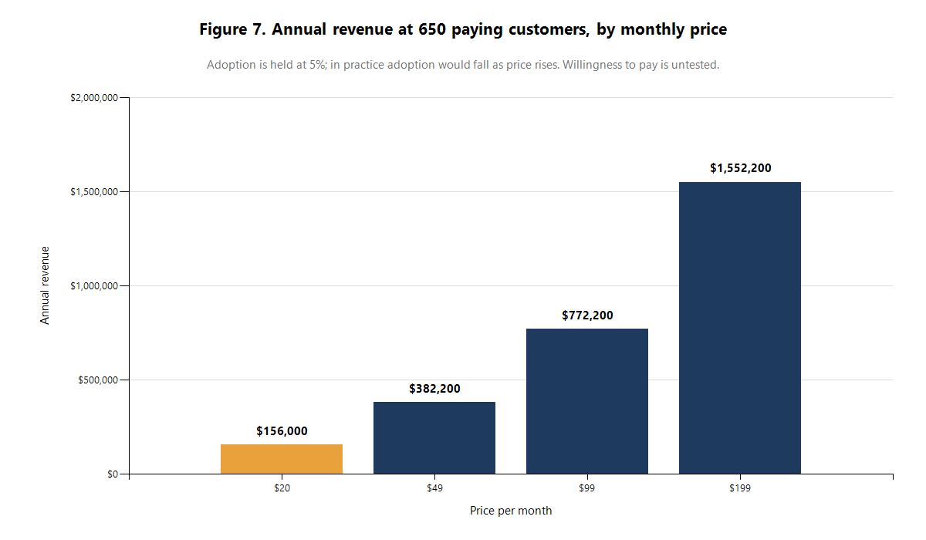6.4 Potential Impact of the Marketplace
Aurix could earn additional revenue through a 10% commission on manufacturing orders. Based on estimated order values of $150 to $500, commissions would range from $15 to $50 per transaction, compared with existing CAD and wax service prices of $79 to $200 [12].
If 650 subscribers placed an average of 0.5 orders monthly at a $30 commission, Aurix could generate $117,000 in additional annual revenue, bringing total revenue to approximately $273,000.
However, these estimates remain unverified and depend on attracting craftsmen, encouraging repeat orders, and retaining transactions on the platform. Further customer research and marketplace testing are essential.
7. Risks and Next Steps
Aurix faces several risks, including limited subscription revenue at $20 per month, an untested marketplace, uncertain manufacturing reliability of AI generated designs, and competition from platforms such as Pencil.
To address these challenges, we plan to interview 20 to 30 small jewelers about their design processes, customization challenges, and willingness to pay. We will also compare Pencil's AI agent with a 3D mesh generator using 20 identical ring design prompts, followed by casting trials to assess failures and correction time. Additionally, we will approach 5 to 10 craftsmen to evaluate marketplace participation and preferred terms, and test demand through landing pages offering $20 monthly and higher priced subscriptions. These steps will help validate our assumptions and assess Aurix's long term viability.

Appendices
Appendix A. TAM, SAM, SOM assumptions table
# | Input | Conservative | Base | Optimistic | Status
1 | Retailers with payroll, all sizes | 19,348 | 19,348 | 19,348 | Sourced: Census 2022 [2]
2 | Manufacturers with payroll, all sizes | 1,879 | 1,879 | 1,879 | Sourced: Census 2022 [3]
3 | Retailers with no employees | 57,102 | 57,102 | 57,102 | Sourced: Census 2024 [4]
4 | TAM businesses (1 + 2 + 3) | 78,329 | 78,329 | 78,329 | Calculated
5 | TAM revenue (4 × $240) | $18.80M | $18.80M | $18.80M | Calculated
6 | Retailers with payroll, under 10 employees | 16,671 | 16,671 | 16,671 | Sourced: Census 2022 [2]
7 | Manufacturers with payroll, under 10 employees | 1,554 | 1,554 | 1,554 | Sourced: Census 2022 [3]
8 | Sum of rows 6 and 7 | 18,225 | 18,225 | 18,225 | Calculated
9 | Share of row 8 needing a design tool | 25% | 40% | 50% | Assumption; no source
10 | Share of row 3 needing a design tool | 5% | 10% | 20% | Assumption; lower because many are resellers
11 | SAM customers (8 × 9 + 3 × 10) | 7,411 | 13,000 | 20,533 | Calculated
12 | SAM revenue (11 × $240) | $1.78M | $3.12M | $4.93M | Calculated
13 | Paid adoption of the SAM | 2% | 5% | 10% | Assumption; weakest input
14 | SOM customers (11 × 13) | 148 | 650 | 2,053 | Calculated
15 | Price | $20/month | $20/month | $20/month | Given; one seat, no churn or discounts in revenue
16 | SOM revenue (14 × $240) | $35,573 | $156,002 | $492,790 | Calculated
Sensitivity of the base SOM to adoption:
Adoption | Customers | Annual revenue
1% | 130 | $31,200
3% | 390 | $93,601
5% | 650 | $156,002
10% | 1,300 | $312,005
20% | 2,600 | $624,010
Appendix B. Census employer size breakdown (2022)
Employees | Jewelry retailers | Jewelry manufacturers
All | 19,348 | 1,879
Under 5 | 10,917 | 1,256
5 to 9 | 5,754 | 298
10 to 19 | 2,252 | 146
20 to 49 | 380 | 117
50 to 99 | 36 | 35
100 to 249 | 7 | not shown
Nonemployer jewelry retailers (2024): 57,102 total; 938 C-corporations, 2,426 S-corporations, 51,757 sole proprietors, 1,981 partnerships [4].
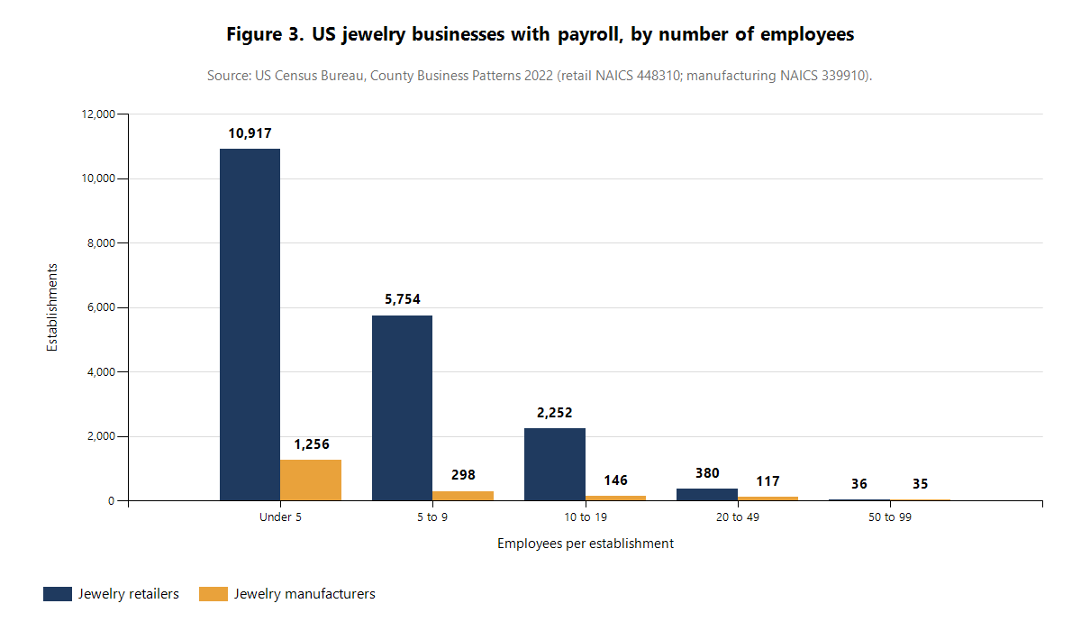
Appendix C. Jewelry CAD job postings
Employer | Pay | Requirements | Source
David Yurman, Tribeca NY, full time, posted April 22, 2026 | $52 to $62/hr | Rhino required; 5 to 7 years of jewelry CAD; builds stone settings, clasps, hinges; repairs meshes; reviews vendor CAD files | [8]
Rio Casting Inc, in person | $25 to $35/hr | Rhino or MatrixGold; Photoshop, Illustrator | [9]
Bocaj Narima Inc, in person | From $30/hr, 40 to 50 hours a week, with benefits | Rhino and Matrix Gold, both mandatory | [10]
Diamonds Direct, New York | $29.00 to $38.50/hr | Rhino, Matrix (Gold) or 3Design; 2 to 5+ years (copies disagree) | [11] (seen in a search summary only)
What employers pay for: production-ready CAD files for casting with tolerances for stone setting and metal thickness; stone settings and mechanisms; mesh repair; reviewing vendors’ files; and revisions on deadlines.
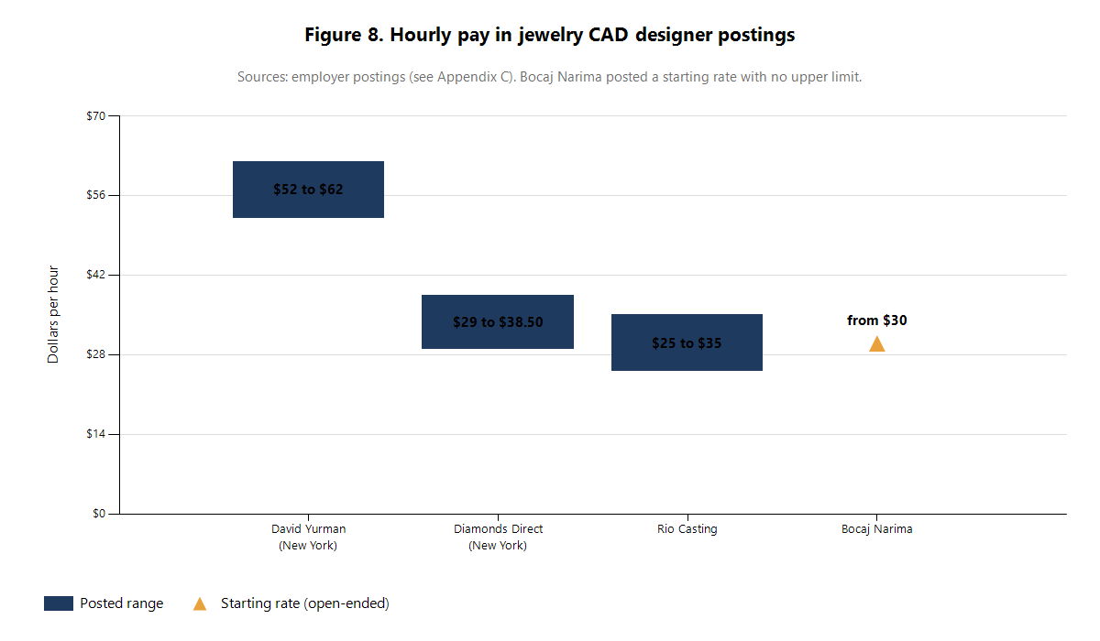
Appendix D. Planned customer interview questions
- How many custom pieces did you sell or make in the last year? How did customers ask for them?
- Who creates the 3D design today: you, an employee, or an outside service? What does it cost and how long does it take?
- What software do you own? What did it cost and how long did you take to learn it?
- When did a custom order go wrong because of the design file? What happened?
- Would you send an AI-generated design directly to a caster? What would you need to see first?
- What would you pay per month for a tool that produced a casting-ready file in minutes?
- Would you order the finished piece from a craftsman through the same platform? What would make you trust them?
Appendix E. Verification log
Read and verified on the page: the Census retail, manufacturing and nonemployer counts; the BLS figures; Pencil, Kickflip, GemFind and MatrixGold prices; the David Yurman, Rio Casting and Bocaj Narima postings; the Diatech and RhinoArtisan announcements; the Text2CAD-Bench, RealCADBench, MUSE and DreamFusion abstracts; the Meshy test; the forum quotes marked above.
Seen only in search summaries (treat as unverified): Pencil’s agent launch date and Pencil’s funding; the GemFind 2010 launch page; the Diamonds Direct posting; the Localogy 89% figure; the National Jewelers Association 68% prediction.
Not done or not available: customer interviews; Reddit and app-store reviews; Capterra and G2 reviews; any independent test of the 2026 AI products; sourced values for custom-work share, adoption, churn, margin and take rate.
Corrections made during research: an earlier draft said 87% (16,923) of employer retailers have under 10 employees; the correct figure is 86% (16,671).
References
[1] US Bureau of Labor Statistics, Jewelers and Precious Stone and Metal Workers. https://www.bls.gov/ooh/production/jewelers-and-precious-stone-and-metal-workers.htm
[2] US Census Bureau, County Business Patterns 2022, NAICS 448310. https://data.census.gov/table/CBP2022.CB2200CBP?q=NAICS+448310+jewelry+stores&y=2022
[3] US Census Bureau, County Business Patterns 2022, NAICS 339910. https://data.census.gov/table/CBP2022.CB2200CBP?q=NAICS+339910+jewelry&y=2022
[4] US Census Bureau, Nonemployer Statistics 2024, US file. https://www2.census.gov/programs-surveys/nonemployer-statistics/datasets/2024/historical-datasets/nonemp24us.zip
[5] Stuller, MatrixGold. https://www.stuller.com/MatrixGold
[6] JCK, “Technology & Tools: World Gone CAD,” April 28, 2011. https://jckonline.com/?p=22766
[7] Rapaport, “Tackling the Bench Jeweler Shortage.” https://rapaport.com/magazine-article/tackling-the-bench-jeweler-shortage/
[8] David Yurman, CAD Designer posting. https://www.career.com/job/davidyurman/cad-designer/j202604210912283806595
[9] Rio Casting Inc, Jewelry CAD Designer posting. https://app.qureos.com/jobs/jewelry-cad-designer-1777566925277
[10] Bocaj Narima Inc, Jewelry CAD Designer posting. https://app.qureos.com/jobs/jewelry-cad-designer-1764324176337
[11] Diamonds Direct, CAD Designer posting. https://www.mediabistro.com/jobs/1982774928-cad-designer
[12] Jewelry by Johan, CAD rendering service. https://jewelrybyjohan.com/shop/custom-jewelry-option-cad-rendering-1561/
[13] 25 Karats, custom design jewelry. https://25karats.com/custom-design-jewelry
[14] Global Market Insights, Wedding Ring Market. https://www.gminsights.com/industry-analysis/wedding-ring-market/amp
[15] Pencil, Shopify App Store listing. https://apps.shopify.com/pencil-shop
[16] Jewellery Monthly, “Pencil Launches AI Jewellery CAD Design Agent.” https://jewellerymonthly.co.uk/pencil-launches-ai-jewellery-cad-design-agent/
[17] The Tribune, Diatech image-to-CAD announcement, February 2026. https://www.tribuneindia.com/news/business/diatech-pioneering-ai-powered-image-to-cad-technology-for-the-global-jewelry-industry/
[18] American Gem Society, “Star Gems Expands GemArt AI.” https://www.americangemsociety.org/star-gems-expands-gemart-ai-to-help-retailers
[19] RhinoArtisan, Generative AI for jewelry design, July 2026. https://rhinoartisan.com/blog/generative-ai-for-jewelry-design/
[20] Text2CAD-Bench, arXiv 2605.18430. https://arxiv.org/abs/2605.18430
[21] RealCADBench, arXiv 2609.03773. https://arxiv.org/abs/2609.03773
[22] MUSE, arXiv 2605.28579. https://arxiv.org/abs/2605.28579
[23] Meshy, “Best AI Tools for 3D Printing in 2026” (vendor-run test). https://www.meshy.ai/blog/best-ai-tools-for-3d-printing
[24] T23D-CompBench, arXiv 2509.23841. https://arxiv.org/abs/2509.23841
[25] DreamFusion, arXiv 2209.14988. https://arxiv.org/abs/2209.14988
[26] GemFind newsletter, February 9, 2010. https://blog.gemfind.com/blog-test/gemfind-diamond-search-web-development-jewelcloud-ring-builder-stud-builder-pendant-builder-2010-02-09
[27] Kickflip pricing. https://gokickflip.com/pricing
[28] GemFind RingBuilder, Shopify listing and reviews. https://apps.shopify.com/gemfind-ring-builder
[29] Kickflip, Shopify one- and two-star reviews. https://apps.shopify.com/mycustomizer-1/reviews?ratings%5B%5D=1&ratings%5B%5D=2&sort_by=newest
[30] Pencil, Shopify reviews. https://apps.shopify.com/pencil-shop/reviews
[31] Ganoksin forum, “CAD decision,” 2013. https://orchid.ganoksin.com/t/cad-decision-any-thoughts-or-direction/40598
[32] Ganoksin forum, “Rhino & Rhinogold vs. Matrix,” 2009. https://orchid.ganoksin.com/t/rhino-rhinogold-vs-matrix/36962
[33] Ganoksin forum, “Pricing CAD/CAM service,” 2004. https://orchid.ganoksin.com/t/pricing-cad-cam-service/24240
[34] Software Advice, Rhino 7 reviews. https://www.softwareadvice.com/fashion-design/jewelry-modeling-profile/reviews/
[35] McNeel forum, “MatrixGold and Rhino 7.” https://discourse.mcneel.com/t/matrixgold-and-rhino-7/113097
[36] McNeel forum, “RhinoGold 6.6 for Rhino 8.” https://discourse.mcneel.com/t/rhinogold-6-6-for-rhino-8/178323
[37] Localogy, small business SaaS adoption. https://www.localogy.com/?p=41111
[38] CB Insights, Pencil. https://www.cbinsights.com/company/pencil-4
[39] Fiverr, 3D CAD jewelry design listing. https://fiverr.com/jewellryexpert/create-3d-cad-jewelry-designs-for-printing

